**Project Report :Reservation and Advertisement Platform Development**

1. **Introduction**

The project aims to develop a user-friendly reservation and advetissement platform for online reservation, enabling customers to browse different products, and track their reservation efficiently. The platform also includes an an admin dashboard for inventory and reservation and advertisement management.

1. Objectives

* Provide a seamless reservation experience.
* To design and implement for service providers to post advertisement
* Implement secure reservation
* To create a module for service provides to post advertisement
* To provide an administrator interface for managing platform operations
* To ensures secure and responsive user experience across devices.

1. Technologies Used

* Frontend: html, css, javascript
* Backend: php
* Database: mySQL
* Deployment: Github

1. Features

Customer Features:

* Search and browse services and products by category, location and availability
* Make, view, and cancel reservation
* Receive notification on advertisement performance

Admin Side:

* Add, edit, and delete products
* Manage customer orders
* Reservation analytics

Service Provider Features

* Register and log in security
* Post, edit and manage advertisements
* View statisitcs on advertisement performance

1. System Design
   1. Class Diagram

The system’s class diagram below shows the relationship between users, Reservations, Advertisement, and Admin functions

Class diagram illustrations

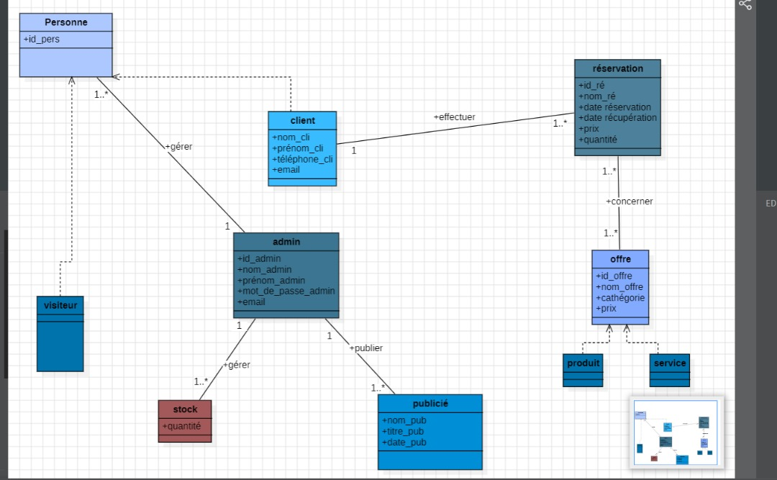

* 1. Use case Diagram

The following use case diagram diagram illustrates the reservation process:

